WEEK-7---SNS,SQS & S3-SNS-SQS-LAMBDA SERVICES

Amazon Simple Notification Service (AWS SNS)
Amazon SNS (Simple Notification Service) offered by AWS (Amazon Web Services) is an overseen service that provides message delivery or sending of messages to subscribing endpoints or clients. It is a completely controlled messaging service that is highly available,durable, and secure.
What is AWS SNS
Amazon SNS stands for Simple Notification Service, which is utilized to convey the pushmessages from the application to the subscribing ends or other applications. It is a completely managed messaging service for
both application to application (A2A) and application to person (A2P) communication. It provides the
ability to create a Topic that is a logical access point and communication channel. Each topic has a different
name that identifies the SNS endpoint for publishers to post messages and subscribers to register for
notifications.
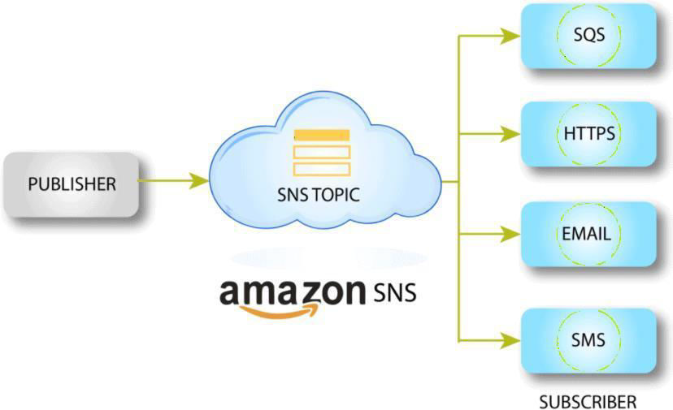

Feature of Amazon SNS
Automatic Scaling: It scales consequently if the number of messages increases. Message Encryption: It provides encrypted topics to protect your messages fromunapproved and unknown access. The message gets decrypted as they are deliveredto subscribing endpoints.
Message Filtering: It enables the subscriber to modify a filter policy so that itonly gets the notifications it is interested in.
Message Fanout: It takes place when a message is sent to a topic and then
replicated and pushed to multiple endpoints. Fanout gives asynchronous event notifications, which in turn
allows for parallel processing.
Mobile Notification: It can be activated by user-driven actions within an application or from business logic
within the cloud. It is low-cost to fanout mobile push notifications for iOS, Android, Fire OS, Windows, and
Baidu-based devices. SNS & Email Messages: Amazon SNS provides the features to send text messages
and email (SMTP).



WEEK-8---SNS,SQS & S3-SNS-SQS-LAMBDA SERVICES

Amazon Simple Notification Service (AWS SNS)
Amazon SNS (Simple Notification Service) offered by AWS (Amazon Web Services) is an overseen service that provides message delivery or sending of messages to subscribing endpoints or clients. It is a completely controlled messaging service that is highly available,durable, and secure.
What is AWS SNS
Amazon SNS stands for Simple Notification Service, which is utilized to convey the push messages from the application to the subscribing ends or other applications. It is a completely managed messaging service for both application to application (A2A) and application to person (A2P) communication. It provides the ability to create a Topic that is a logical access point and communication channel. Each topic has a different name that identifies the SNS endpoint for publishers to post messages and subscribers to register for notifications.
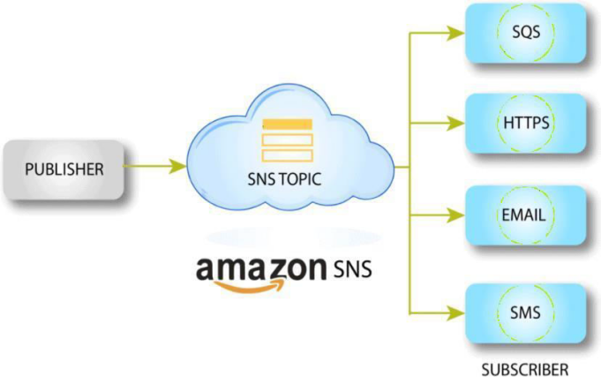

Feature of Amazon SNS
Automatic Scaling: It scales consequently if the number of messages increases. Message Encryption: It provides encrypted topics to protect your messages from unapproved and unknown access. The message gets decrypted as they are delivered to subscribing endpoints.
Message Filtering: It enables the subscriber to modify a filter policy so that itonly gets the notifications it is interested in.
Message Fanout: It takes place when a message is sent to a topic and then
replicated and pushed to multiple endpoints. Fanout gives asynchronous event notifications, which in turn allows for parallel processing.
Mobile Notification: It can be activated by user-driven actions within an application or from business logic within the cloud. It is low-cost to fanout mobile push notifications for iOS, Android, Fire OS, Windows, and
Baidu-based devices. SNS & Email Messages: Amazon SNS provides the features to send text messages
and email (SMTP).



Amazon SQS (Simple Queue Service)
Amazon Simple Queue Service (SQS) is a fully managed message queuing service provided by Amazon Web Services that enables distributed applications to communicate with each other in a decoupled and scalable manner. It allows different components of an application to send and receive messages without directly interacting with each other.
SQS works by storing messages in a queue until they are processed by the receiving application. The application that sends the message is called the producer, and the application that receives and processes the message is called the consumer.

Types of SQS Queues
Standard Queue
Provides maximum throughput.
Messages are delivered at least once.
Message ordering is not guaranteed
FIFO Queue (First-In-First-Out)
Guarantees exactly-once message processing
Maintains strict order of messages.
Used when message order is important.

Features of SQS
Fully managed and highly scalable.
Secure and reliable message delivery.
Supports asynchronous communication between services.
Integrates with many AWS services like EC2 and Lambda.

Advantages
Improves application scalability and reliability.
Reduces tight coupling between system components.
Handles large volumes of messages efficiently.
Example: In an e-commerce system, order requests can be placed in an SQS queue and processed by backend services without delaying the user request.

1) Simple Notification Sevice (SNS)

A) Create SNS Topic and Send Message to Email
We will:
- Create an SNS Topic
- Create an Email Subscription
- Confirm the subscription
- Publish a test message

Step 1: Create SNS Topic
- Login to AWS Console
- In search bar → Type SNS
- Open Amazon SNS (Simple Notification Service)
- In left panel → Click Topics
- Click Create topic

Configure:
- Type → Select Standard
- Name → MyEmailTopic
- Leave other settings default (unless required)
- Click Create topic
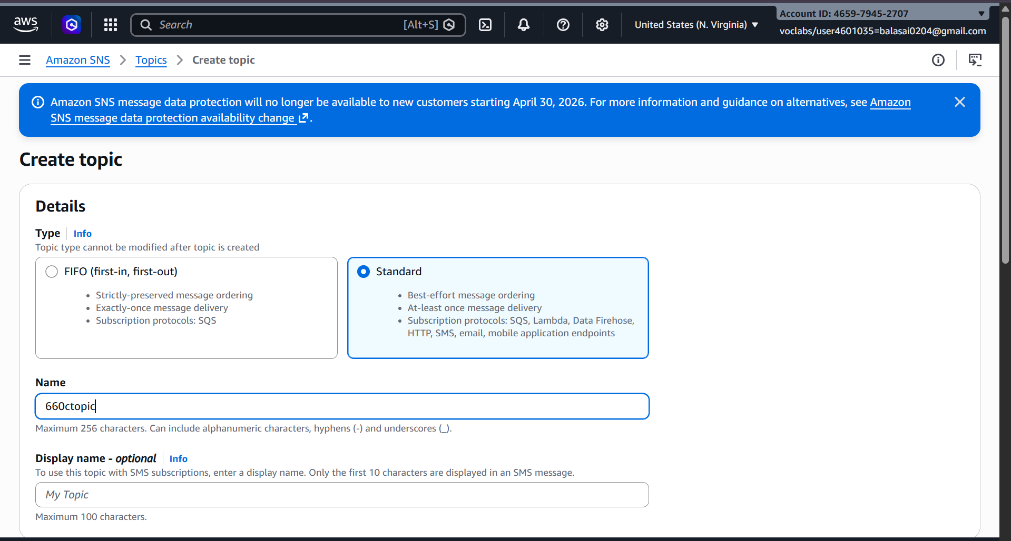

Step 2: Create Email Subscription
- Open your created topic
- Go to Subscriptions tab
- Click Create subscription

Configure:
- Protocol → Select Email
- Endpoint → Enter your email address
- Click Create subscription
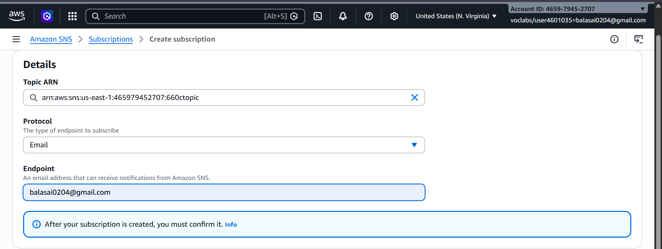

Step 3: Confirm Subscription
- Go to your email inbox
- You will receive a mail from Amazon SNS
- Click Confirm subscription
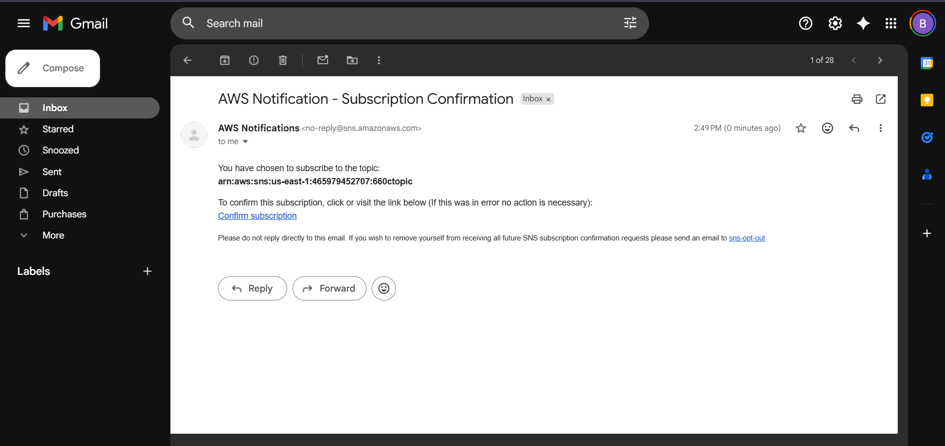
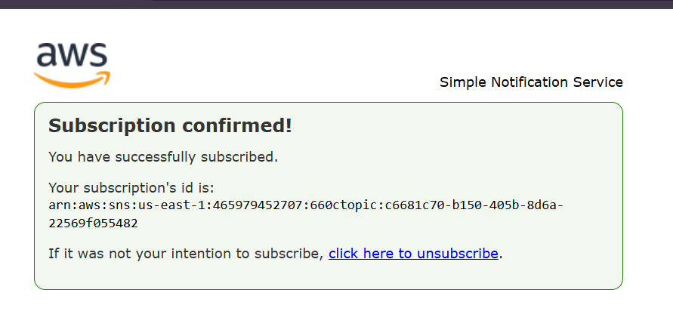
Now your email is successfully subscribed 🎉

Step 4: Publish Test Message
- Open your SNS topic
- Click Publish message
- Add:
  - Subject → Test Mail
  - Message body → Hello this is SNS test
- Click Publish message
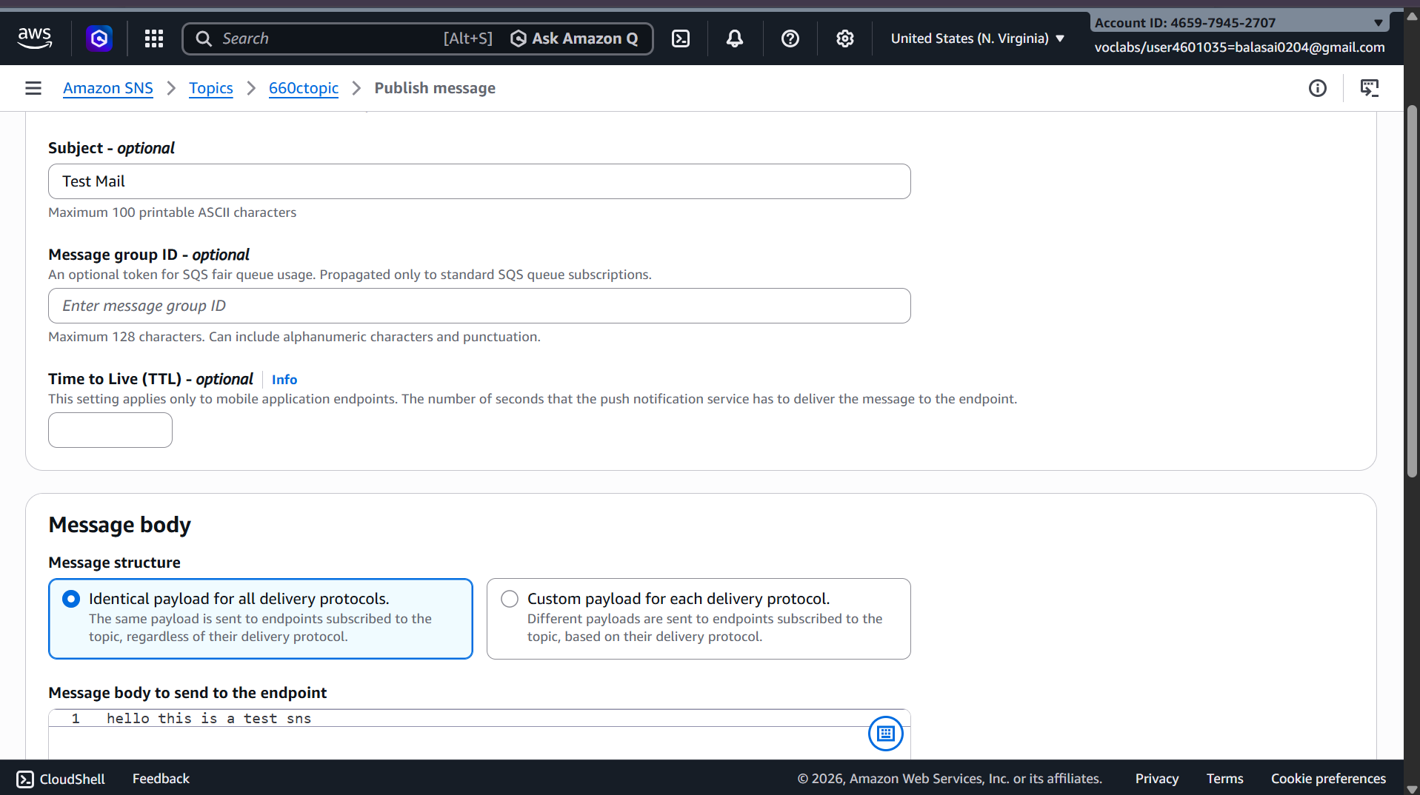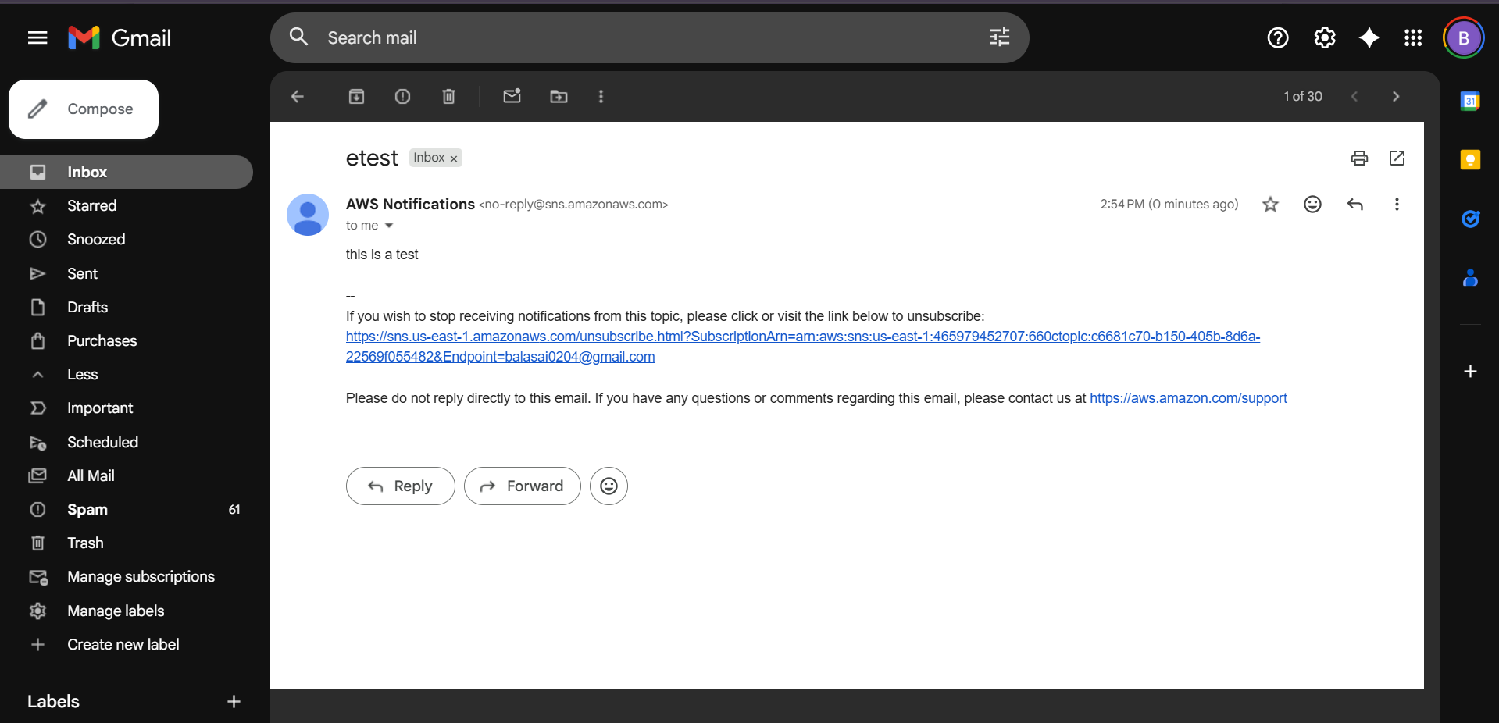

You will receive email notification.

B) Trigger Email When S3 Object is Uploaded (S3 → SNS → Email)
Now we extend this setup:
Flow:
S3 Bucket → Event Notification → SNS Topic → Email

Step 1: Create S3 Bucket
- Search → S3
- Click Create bucket

Configure:
- Bucket name → my-upload-bucket-2026
- Choose Region (Important: Same region as SNS topic)
- Keep default settings (unless specific requirement)
- Click Create bucket
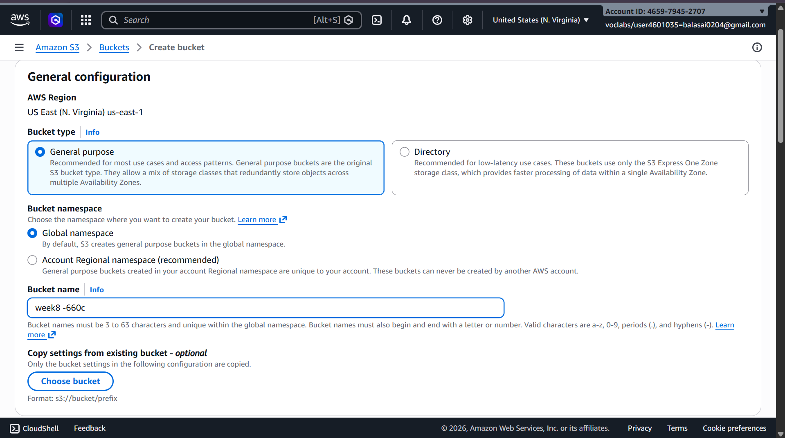

Step 2: Create SNS Topic (If not already created)
You can reuse the topic from Part A
OR create new topic like:
- Topic name → S3UploadNotification
Make sure email subscription is confirmed.
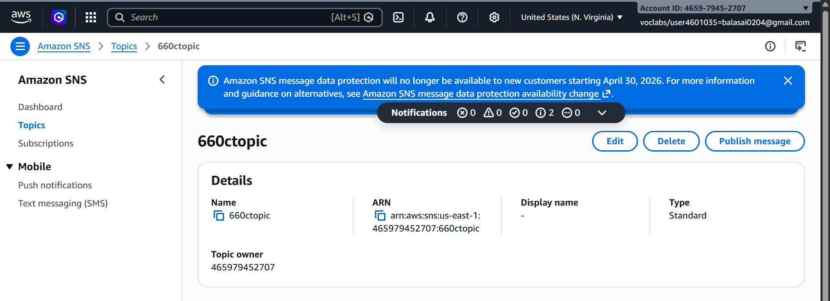

Step 3: Allow S3 to Publish to SNS (Access Policy)
- Open SNS Topic
- Go to Access policy
- Click Edit
Add permission for S3 to publish.
If using Basic Editor:
Access Policy that needs to be configured on SNS:
a) replace SNS topic ARN
b) Replace s3 bucket ARN
c) Replace account
{
"Version": "2012-10-17",
"Id": "example-ID",
"Statement": [
{
"Sid": "Example SNS topic policy",
"Effect": "Allow",
"Principal": {
"Service": "s3.amazonaws.com"
},
"Action": [
"SNS:Publish"
],
"Resource": "SNS topic ARN",
"Condition": {
"ArnLike": {
"aws:SourceArn": "s3 bucket ARN"
},
"StringEquals": {
"aws:SourceAccount": "account id"
}
}
}
]
}
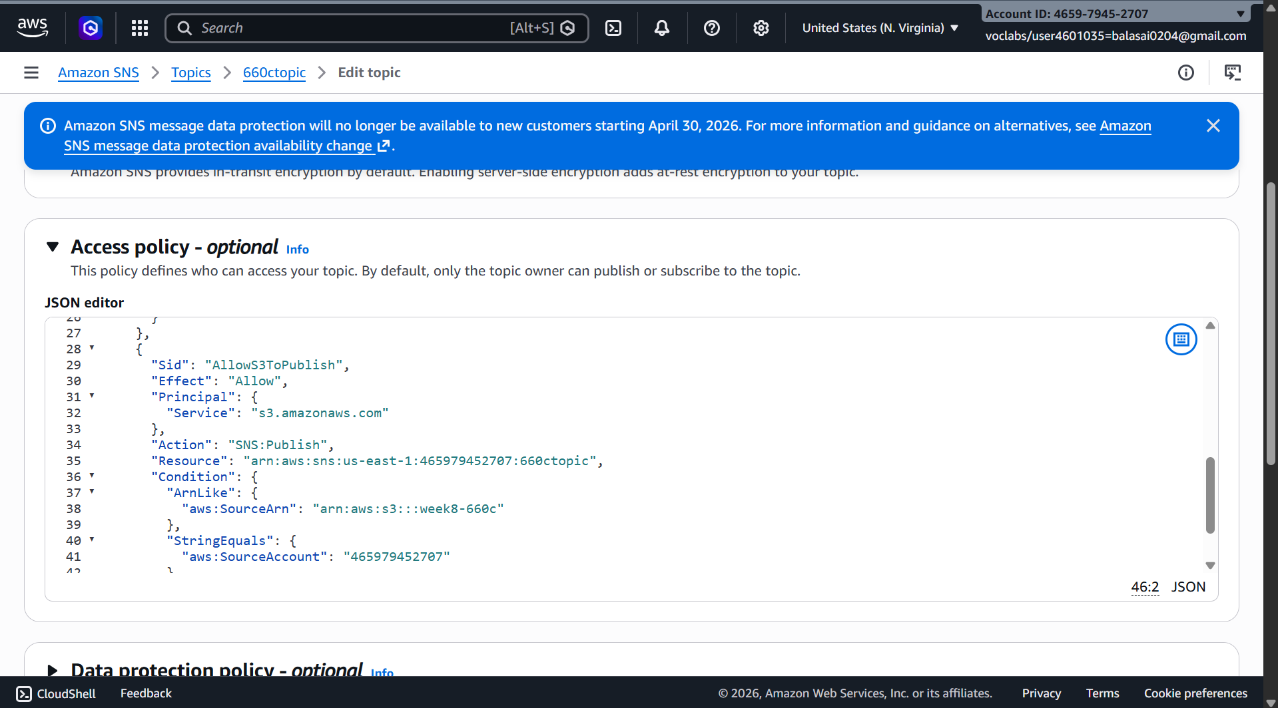

(Modern AWS console often auto-generates this when configuring from S3)

Step 4: Configure S3 Event Notification
- Open your S3 bucket
- Go to Properties
- Scroll to Event notifications
- Click Create event notification

Configure:
- Event name → UploadNotification
- Event types → Select:
  - All object create events
- Destination:
  - Select SNS topic
  - Choose your topic (S3UploadNotification)
- Click Save changes
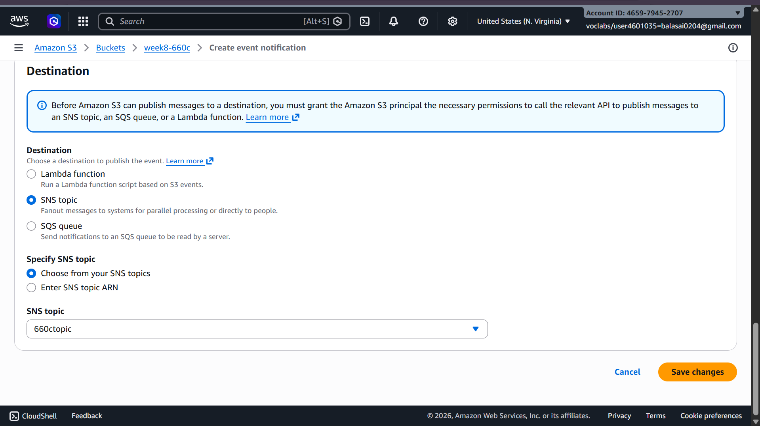

Step 5: Test It
- Upload any file into the S3 bucket
- After upload completes:
  - S3 triggers event
  - SNS receives publish request
  - SNS sends email
You will receive mail about object upload.
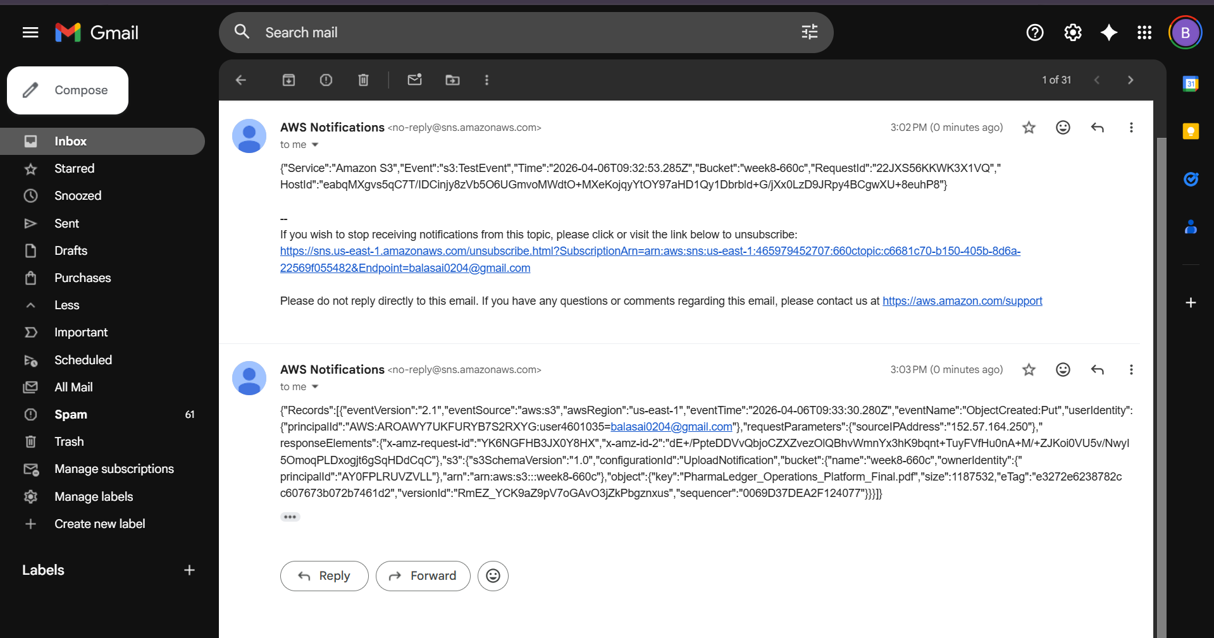

Simple Queue Service (SQS)
Objective:
- S3 sends a notification to SNS
- SNS forwards the message to SQS
- SQS stores the message
- Lambda automatically reads and processes the message

2) Create SQS Queue and Send Message
We will:
- Create an SQS Queue
- Send a message to the Queue
- Receive the message from the Queue

Step 1: Create SQS Queue
- Login to AWS Console
- In the search bar → Type SQS
- Open Amazon Simple Queue Service
- In the dashboard → Click Create queue
Configure:
• Type → Select Standard
• Name → MyQueue
• Leave other settings as default
- Click Create queue
Your SQS queue is now created successfully.
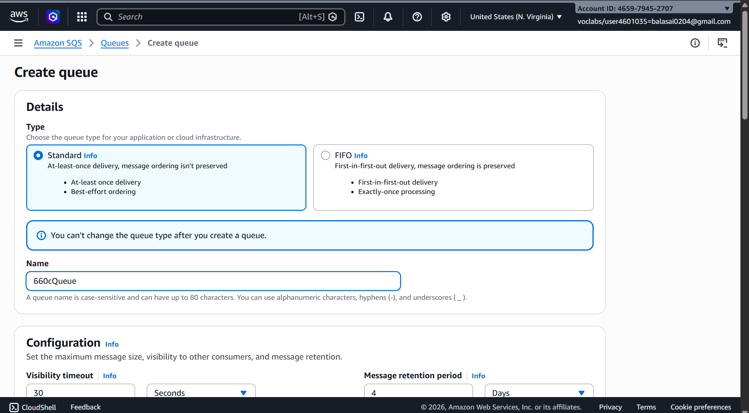

Step 2: Send Message to Queue
- Open the MyQueue queue
- Click Send and receive messages
- In the Message body, type:
Hello this is SQS test message
- Click Send message
Your message is now stored in the queue.
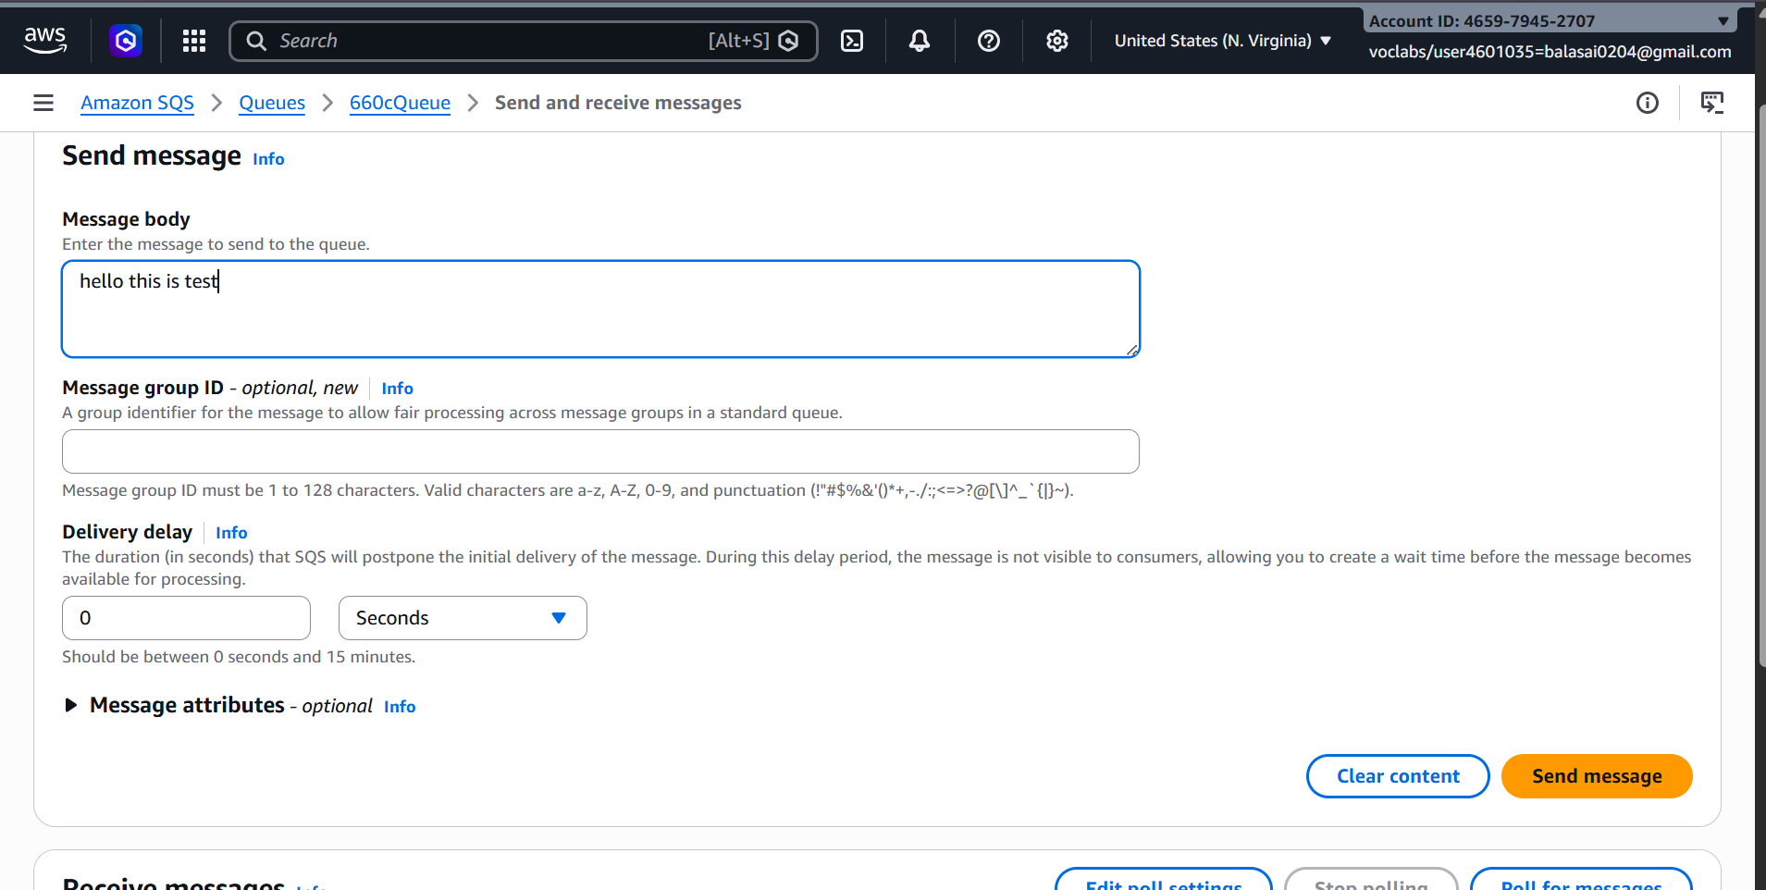

Step 3: Receive Message from Queue
- In the same page (Send and receive messages)
- Click Poll for messages
You will see the message displayed.
Example output:
Hello this is SQS test message
- After processing, click Delete message (optional)
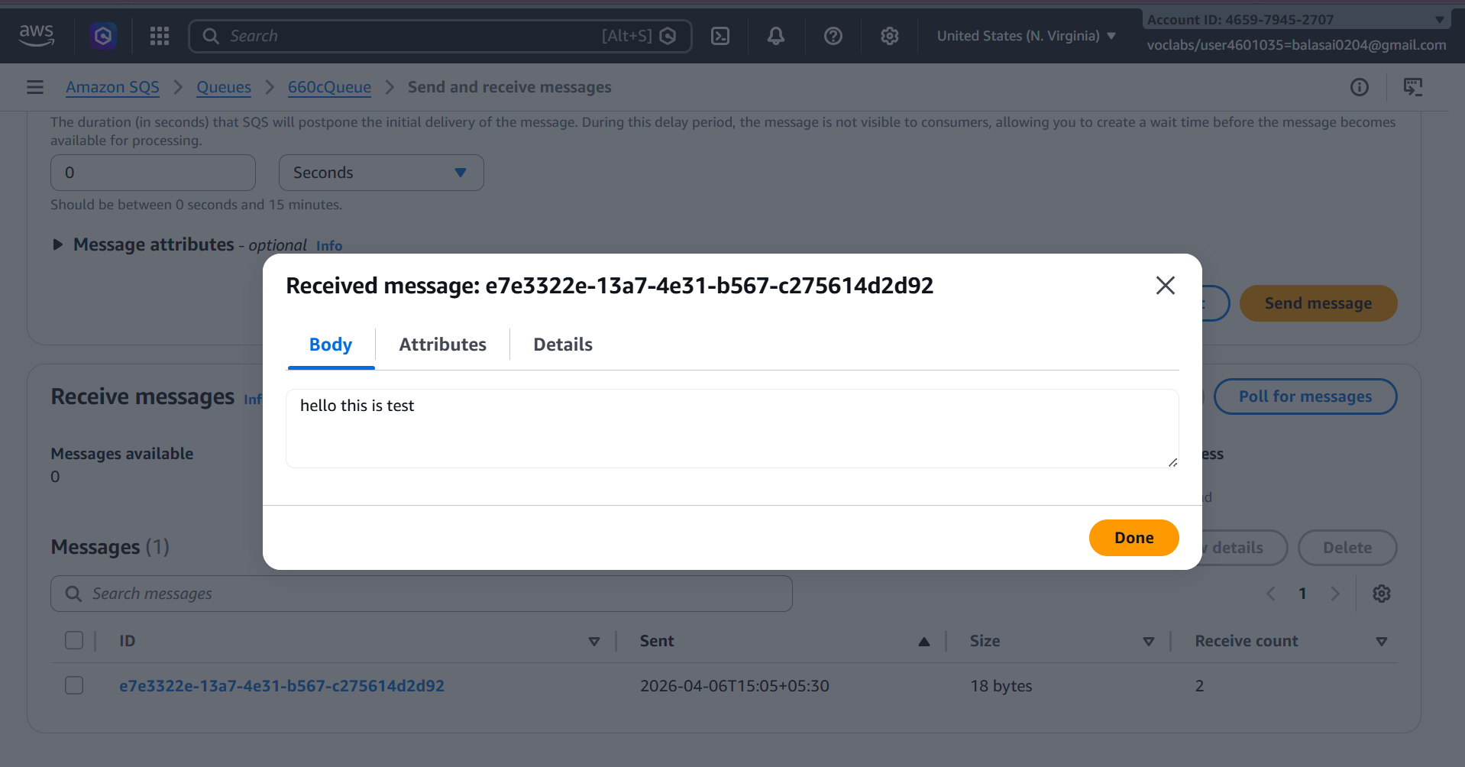

Result:
- SQS queue created
- Message sent successfully
- Message received from queue

3) S3 Bucket Event → SNS → SQS → Lambda Processing
S3 bucket event (like file upload) triggers SNS, which sends the notification to SQS. Then Lambda acts as the consumer and processes the message.
Services used:
• Amazon S3
• Amazon Simple Notification Service
• Amazon Simple Queue Service
• AWS Lambda

S3 → SNS → SQS → Lambda Architecture
S3 Bucket (File Upload)
↓
SNS Topic
↓
SQS Queue
↓
Lambda Function (Consumer)
When a file is uploaded, S3 sends an event notification to SNS, which forwards the message to SQS. The Lambda function then reads and processes the message from SQS.

Step 1: Create S3 Bucket
- Login to AWS Console
- Search S3
- Open Amazon S3
- Click Create bucket
Configure:
• Bucket name → mys3eventbucket123 (must be unique)
• Region → choose your region
Leave other settings default.
- Click Create bucket


Step 2: Create SNS Topic
- Search SNS in AWS Console
- Open Amazon SNS
- Click Topics → Create topic
Configure:
• Type → Standard
• Name → MyS3SNSTopic
- Click Create topic
Copy the SNS Topic ARN. - arn:aws:sns:us-east-1:465979452707:week8part3
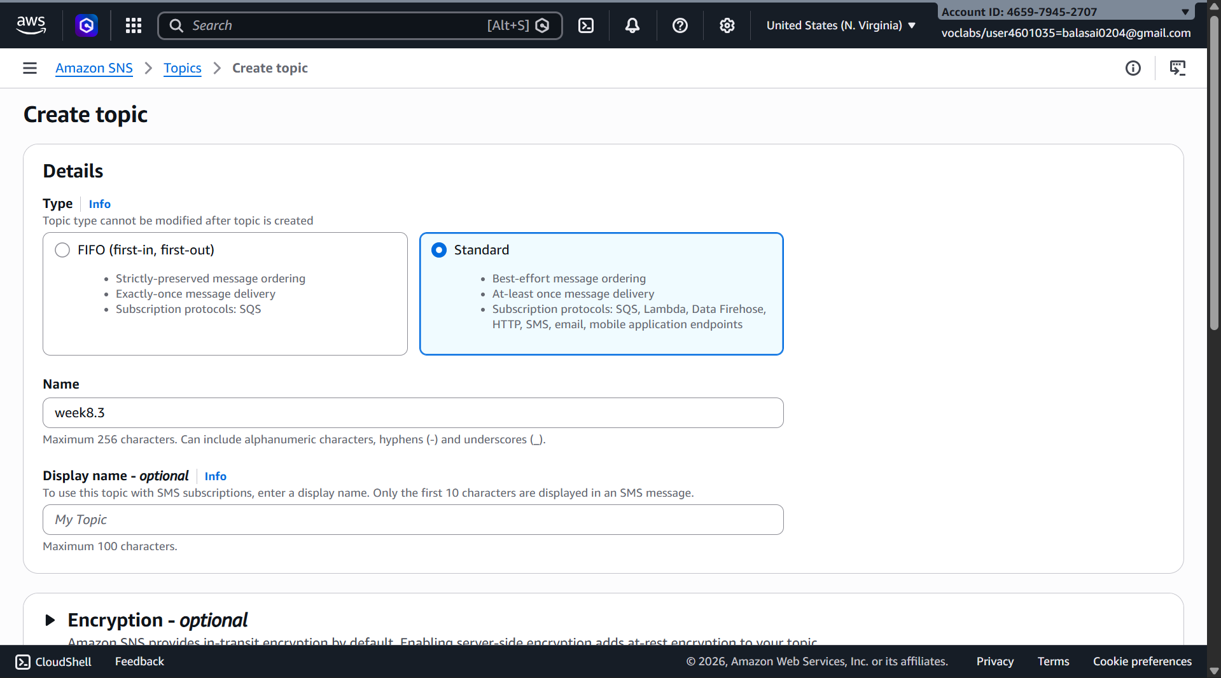

Step 3: Create SQS Queue
- Search SQS in AWS Console
- Open Amazon SQS
- Click Create queue
Configure:
• Type → Standard
• Name → MyS3Queue
- Click Create queue
Copy the Queue ARN. - arn:aws:sqs:us-east-1:465979452707:week8part3
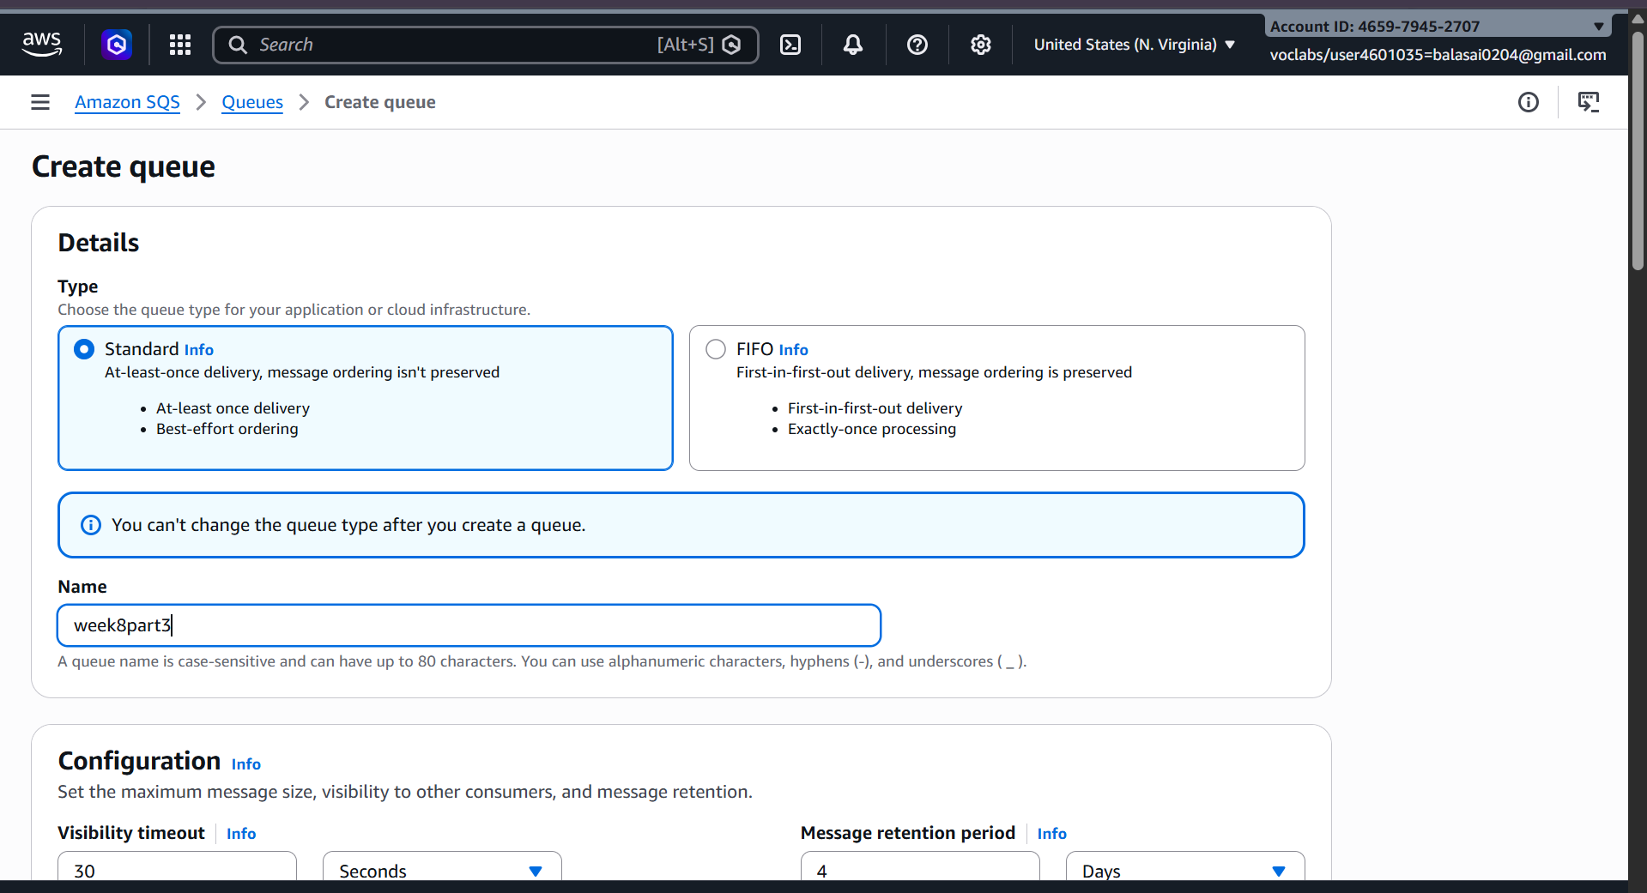

Step 4: Subscribe SQS to SNS
- Open MyS3SNSTopic
- Click Create subscription
Configure:
• Protocol → Amazon SQS
• Endpoint → Select MyS3Queue
- Click Create subscription
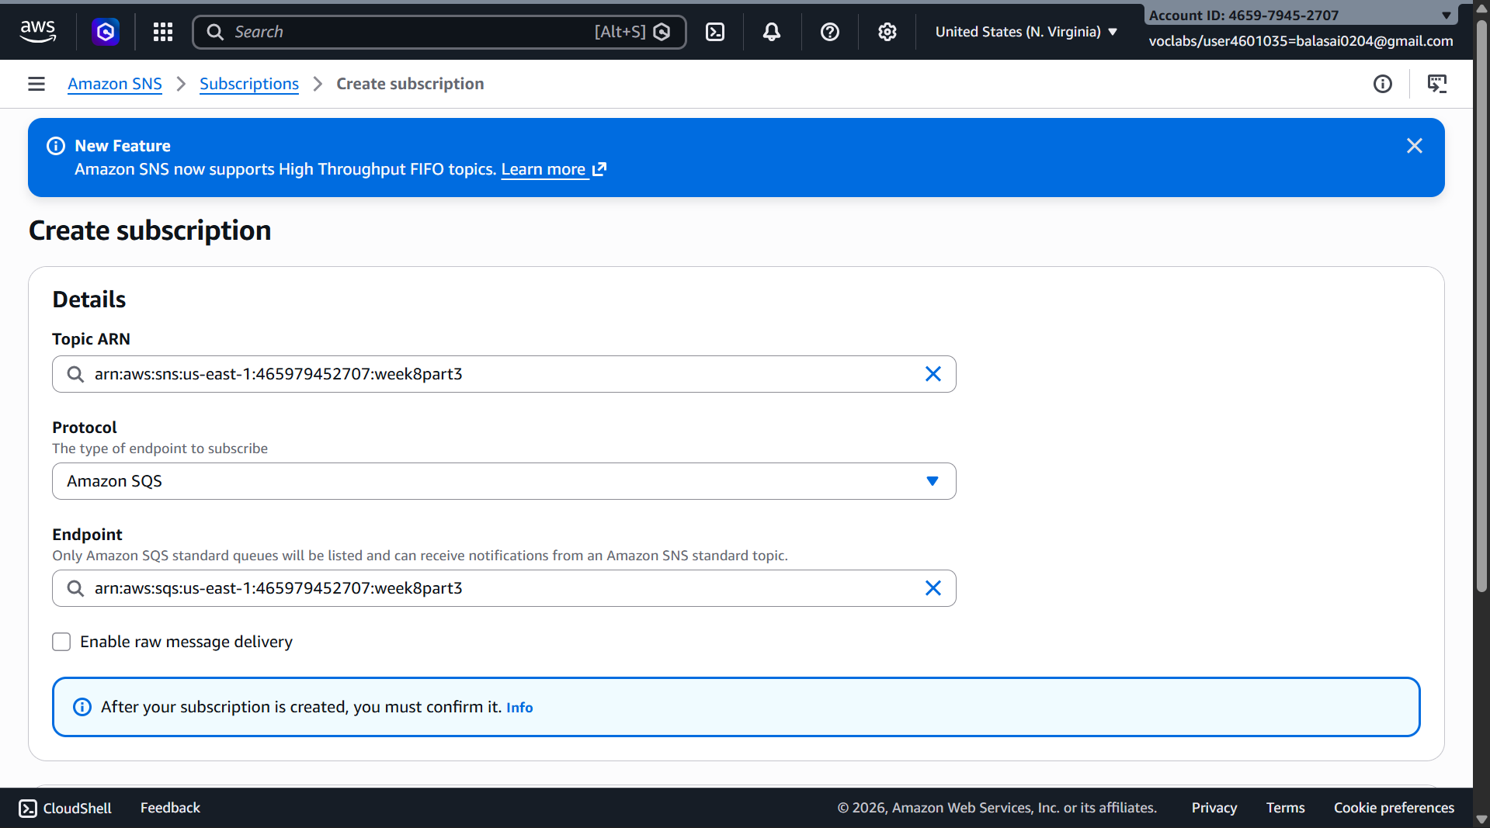

Step 5: Add Access Policy to SQS
Open MyS3Queue → Access Policy → Edit
Replace:
• SQS ARN
• SNS ARN
{
"Statement": [
{
"Effect": "Allow",
"Principal": {
"Service": "sns.amazonaws.com"
},
"Action": "sqs:SendMessage",
"Resource": "SQS ARN",
"Condition": {
"ArnEquals": {
"aws:SourceArn": "SNS ARN"
}
}
}
]
}
Click Save.
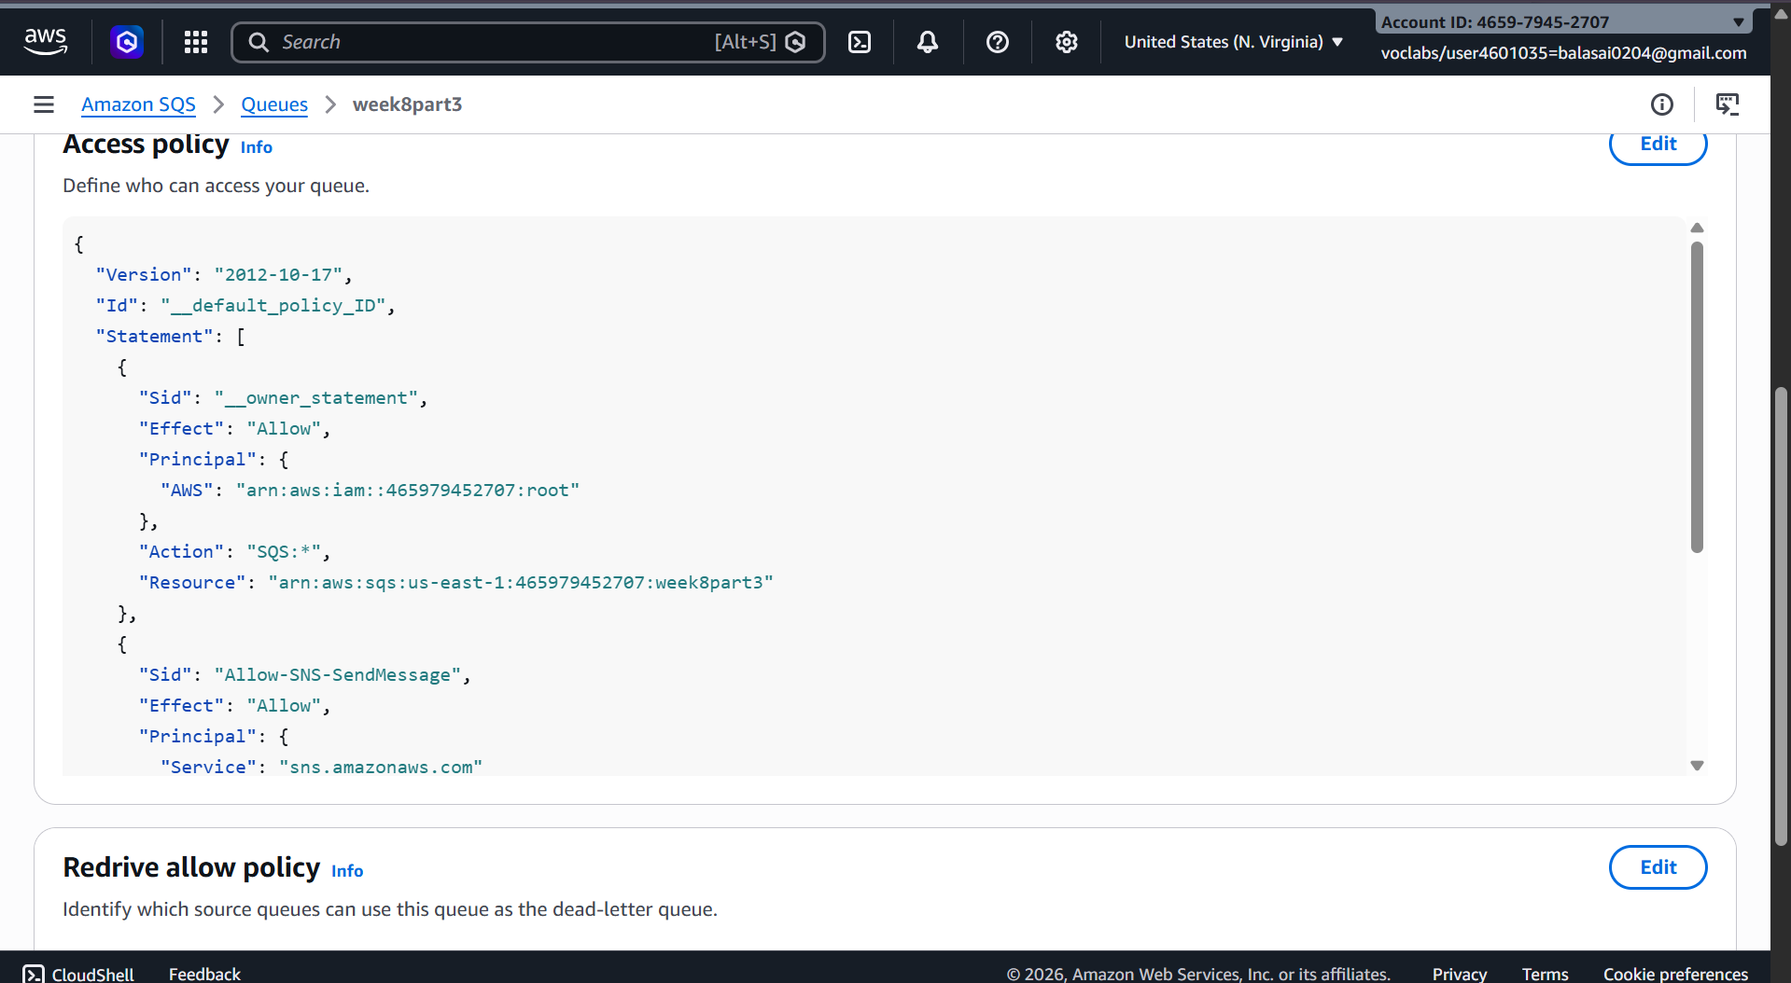

Step 6: Add Access Policy to SNS
Open SNS Topic → Edit access policy
Replace:
• SNS topic ARN
• S3 bucket ARN
• Account ID
{
"Version": "2012-10-17",
"Id": "example-ID",
"Statement": [
{
"Sid": "Example SNS topic policy",
"Effect": "Allow",
"Principal": {
"Service": "s3.amazonaws.com"
},
"Action": [
"SNS:Publish"
],
"Resource": "SNS topic ARN",
"Condition": {
"ArnLike": {
"aws:SourceArn": "S3 bucket ARN"
},
"StringEquals": {
"aws:SourceAccount": "Account ID"
}
}
}
]
}
Save the policy.
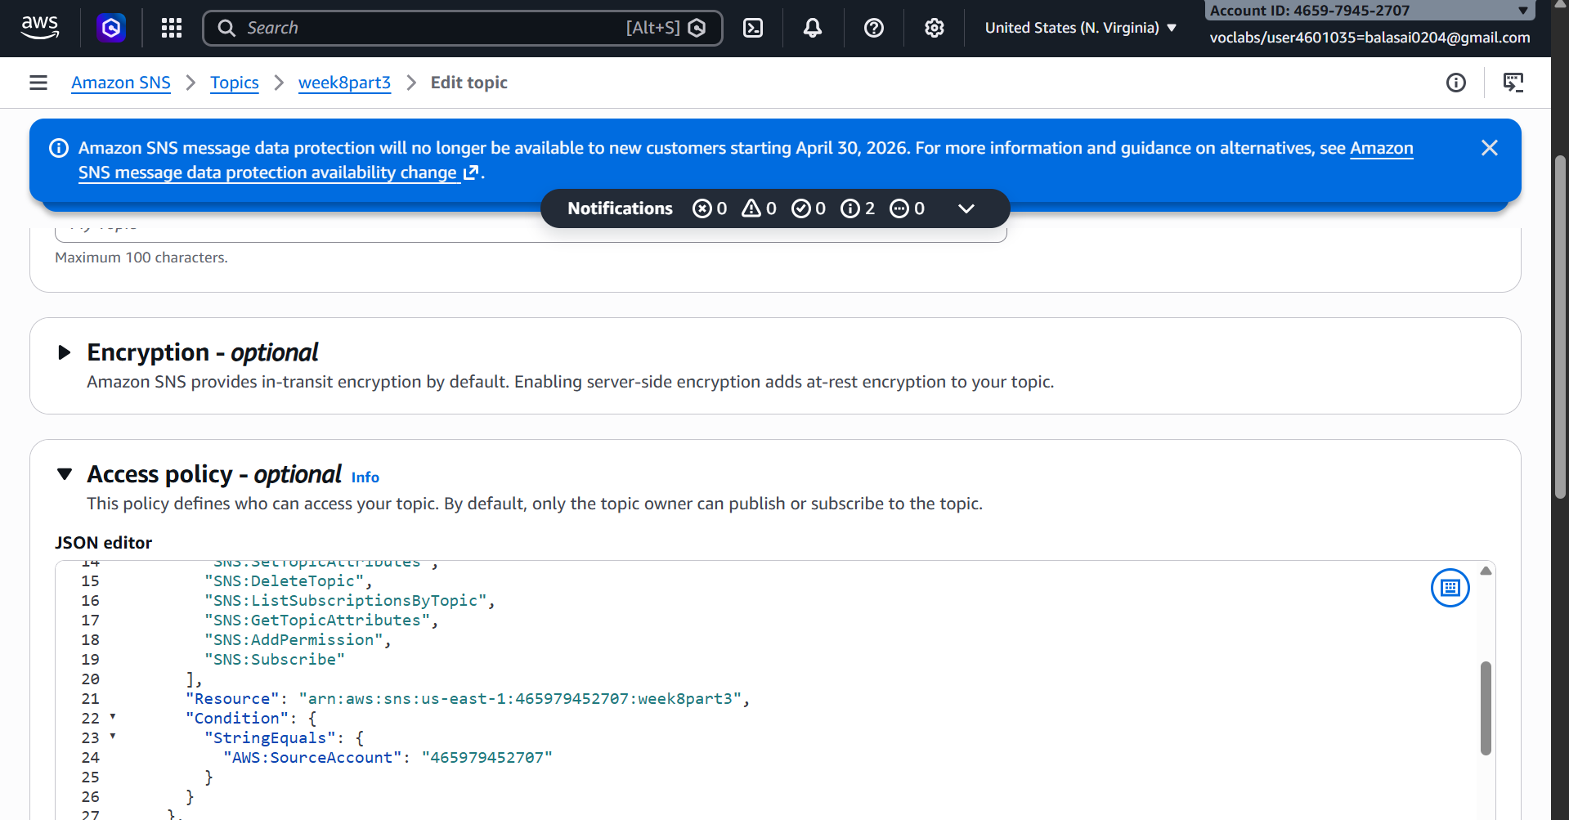

Step 7: Configure S3 Event Notification
- Open S3 Bucket (mys3eventbucket123)
- Go to Properties
- Scroll to Event notifications
Click Create event notification
Configure:
• Event name → S3UploadEvent
• Event type → All object create events
Destination:
• SNS Topic → MyS3SNSTopic
Click Save changes.
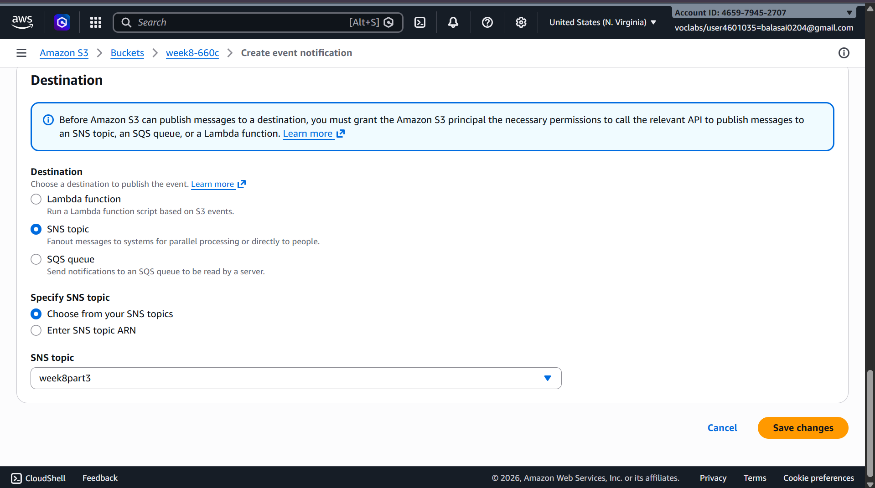

Step 8: Test the Architecture
- Open the S3 bucket
- Click Upload file
- Upload any file (example: test.txt)
Now:
File Upload → S3
↓
Notification → SNS
↓
Message → SQS
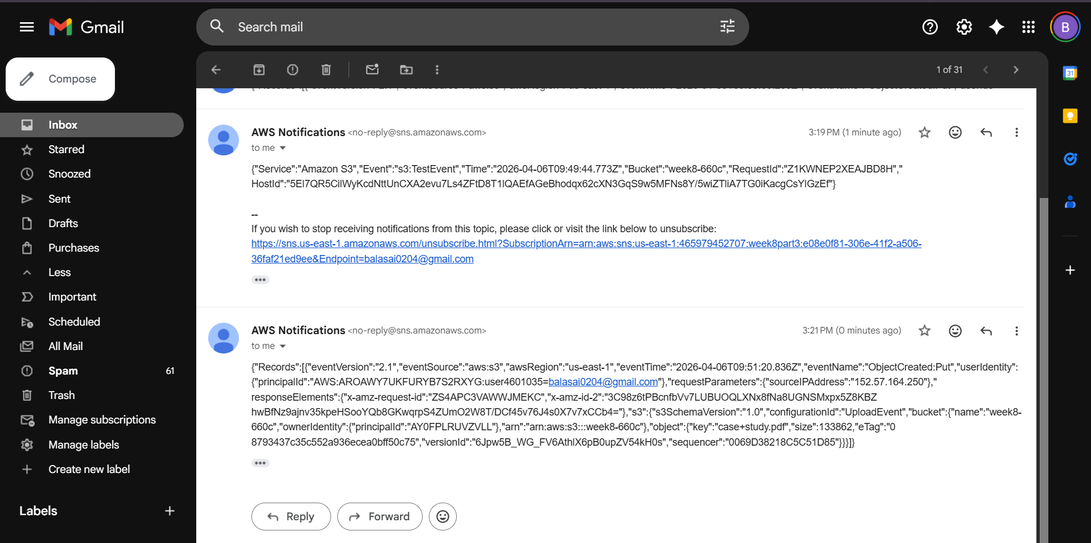

Step 9: Verify Message in SQS
- Open MyS3Queue
- Click Send and receive messages
- Click Poll for messages
You will see the S3 event notification message.
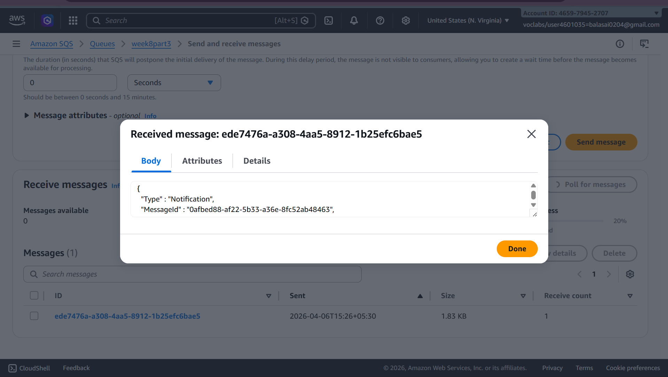

Step 10: Configure Lambda as Consumer
Now configure Lambda to automatically process messages from SQS.
Create Lambda Function
- Search Lambda in AWS Console
- Open AWS Lambda
- Click Create Function
Configure:
• Author from scratch
• Function name → SQSConsumerFunction
• Runtime → Python 3.x
Click Create function
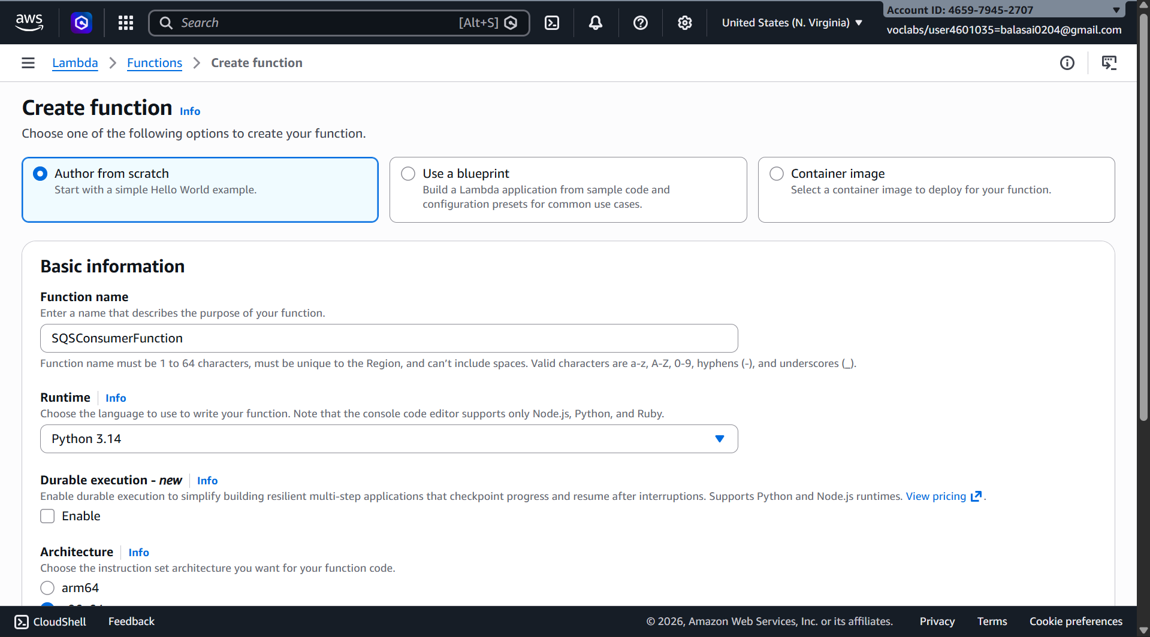

Add SQS Trigger
- Open SQSConsumerFunction
- Click Add Trigger
- Select SQS
- Choose MyS3Queue
Click Add
Now Lambda will automatically read messages from SQS.
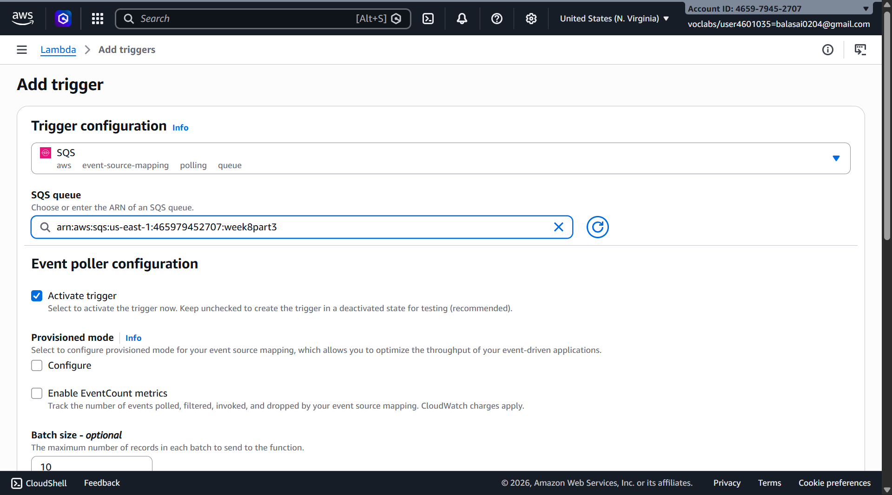

Lambda Code
Replace code with:
def lambda_handler(event, context):

for record in event['Records']:
print("Message received from SQS:")
print(record['body'])

return {
'statusCode': 200,
'body': 'Message processed successfully'
}
Click Deploy.

Final Architecture
User uploads file
↓
Amazon S3
↓
SNS Topic
↓
SQS Queue
↓
Lambda Function (Consumer)
↓
Processing / Logs / Database

Result
When a file is uploaded to S3:
- S3 sends a notification to SNS
- SNS forwards the message to SQS
- SQS stores the message
- Lambda automatically reads and processes the message
This creates a serverless event-driven architecture commonly used in real cloud applications.
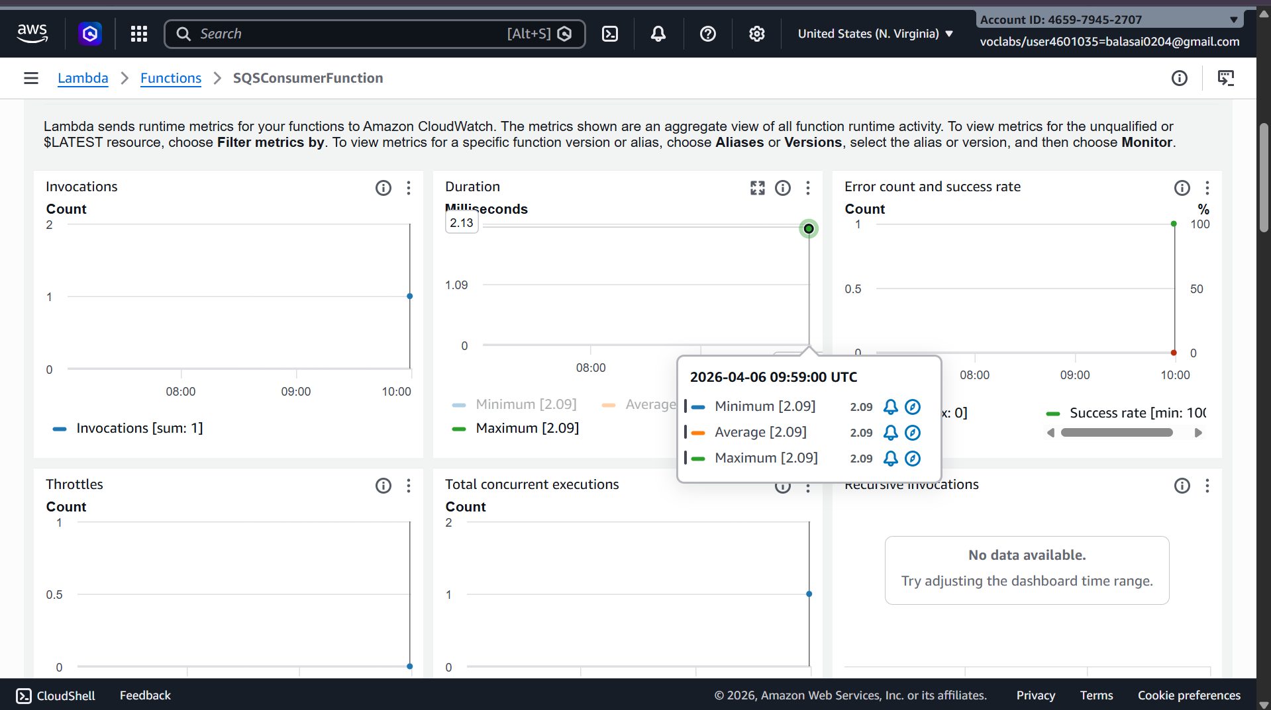

Scenario Based Questions (SNS, SQS, S3-SNS-SQS-Lambda)
1. A company wants to send notifications to multiple users (email, SMS, apps). Which AWS service?
Answer: Amazon SNS

2. SNS email subscription not receiving messages. Why?
Answer: Email subscription not confirmed

3. Notify admins via email when file uploaded to S3. How?
Answer: Amazon S3 → Amazon SNS → Email

4. S3 configured but SNS not receiving message. Why?
Answer: Missing SNS access policy (S3 not allowed to publish)

5. Store messages temporarily for later processing. Which service?
Answer: **
little big aanswers
Got it 👍 slightly detailed but still clean and human-like:

1. A company wants to send notifications to multiple users (email, SMS, apps). Which AWS service?
Answer: Use Amazon SNS. It supports publish-subscribe and can send the same message to multiple endpoints like email, SMS, and applications simultaneously.

2. SNS email subscription not receiving messages. Why?
Answer: Most common reason is the email subscription is not confirmed. The user must click the confirmation link sent by SNS before receiving messages.

3. Notify admins via email when file uploaded to S3. How?
Answer: Configure Amazon S3 event notification to trigger Amazon SNS, and subscribe email to the SNS topic.

4. S3 configured but SNS not receiving message. Why?
Answer: The SNS topic access policy is missing. S3 must be explicitly allowed to publish to SNS using a proper policy.

5. Store messages temporarily for later processing. Which service?
Answer: Use Amazon SQS. It stores messages reliably until they are processed.

6. Messages sent to SQS but not visible. Why?
Answer: Possible reasons include wrong queue, message already consumed, visibility timeout, or sending to a different region/queue.

7. Process thousands of messages without overload. How does SQS help?
Answer: Amazon SQS queues messages and processes them asynchronously, preventing system overload and enabling scalability.

8. Automatically process messages from SQS without polling. Which service?
Answer: Use AWS Lambda. It can be triggered automatically by SQS.

9. Design workflow for S3 upload → notification + processing. How?
Answer: Use S3 → SNS → SQS → Lambda. S3 triggers SNS, SNS sends to SQS, and Lambda processes messages from SQS.

10. SNS to SQS not working. What is missing?
Answer: Missing SQS access policy to allow SNS to send messages to the queue.

11. Decouple application components. Which services?
Answer: Use Amazon SNS + Amazon SQS for loosely coupled architecture.

12. Lambda not triggered from SQS. Why?
Answer: SQS trigger not configured properly or Lambda does not have permission to access the queue.

13. S3 upload → notify + store + async processing. Which architecture?
Answer: Use S3 → SNS → SQS → Lambda serverless architecture.

14. Monitor Lambda processing logs. Which service?
Answer: Use Amazon CloudWatch to view logs and debug.

15. Fully serverless event-driven system for file upload processing. Which services?
Answer: Combine Amazon S3, Amazon SNS, Amazon SQS, and AWS Lambda.

16. Send same message to multiple applications independently. Which service?
Answer: Use Amazon SNS for publish-subscribe model.

17. SNS connected to SQS but messages not appearing. Why?
Answer: Missing SQS access policy allowing SNS to send messages.

18. Store large number of events safely until processed. Which service?
Answer: Use Amazon SQS for reliable message storage.

19. Process S3 uploads with Lambda but avoid data loss. Which architecture?
Answer: Use S3 → SNS → SQS → Lambda so messages are stored safely before processing.

20. Messages remain in SQS after Lambda processing. Why?
Answer: Messages are not deleted after processing or Lambda execution is failing.

